VIAL OF LIFE PLUS
PROGRAM
LIFESAVING INFORMATION FOR EMERGENCIES

+ + + + + + + + + + + + + + + + + + + + + + + + + + + + + + + + + +
What is the VIAL OF LIFE program?

It is a way to have life-saving information available for Emergency Medical Responders in the event that you are injured or ill at your home and are unable to communicate. While it is useful for all family members, it is especially helpful for senior citizens who live alone and or may be chronically ill.
How to use the VIAL OF LIFE?
Use a pencil, put date on top of medical form. Add a picture for ID.
(REMEMBER to update every 6 months and change the DATE on the medical form}

- Complete the medical form carefully and as accurately as possible.
- Put the form and other decision making information back in the plastic bag.
- Tape the bag on the front of your refrigerator door, the decal must be seen.
- The small stickers should be placed on the front and back door above the handle or on a window nearby.

What is the VIAL OF LIFE PLUS?
There are over 100,000 senior citizens (65+) living in Cobb County GA. Some are in difficult circumstances due to the COVID-19 pandemic. To assist our senior community in being prepared to give vital temperature information to their healthcare providers when telecommunicating and to help them protect themselves when in contact with others, the Senior Citizen Council of Cobb created the VIAL OF LIFE PLUS. We have added to our VIAL OF LIFE PROGRAM a digital thermometer, masks, and hand sanitizer (limited supplies).
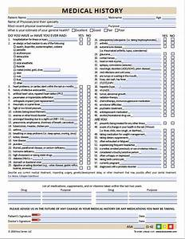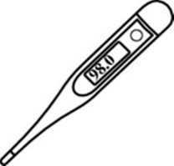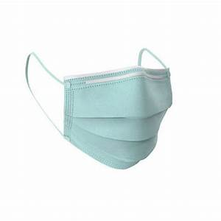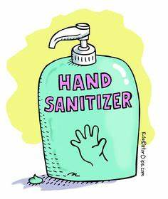
MEDICAL FORM THERMOMETER MASK HAND SANITIZER

Senior Citizen Council of Cobb-. Suite 190- Mailbox 107 - 1750 Powder Springs Rd, Marietta, GA 30064
Phone: 423.815.1790- Email: info@seniorcitizencouncilofcobb.org
Website: https://seniorcitizencouncilofcobb.org

9/2020

